**Module – 10 (API Testing)**

1. to test in above API which is passed in parameter as a column in user module to check the registration performed or not and get the result is coming or not (Method=POST)

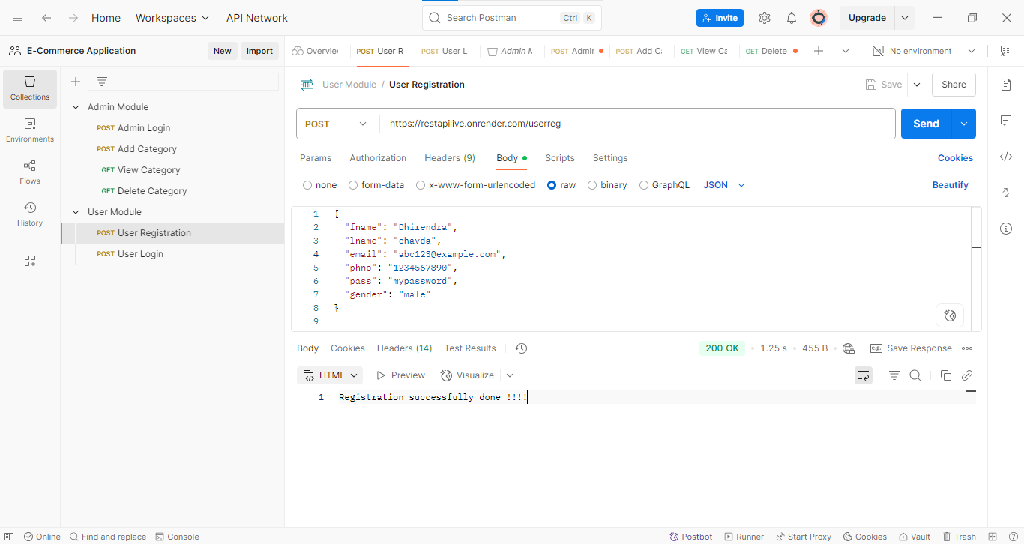

2) to test in above API which is performed login wit using parameter in user module and check generate

token or not (Method=POST)

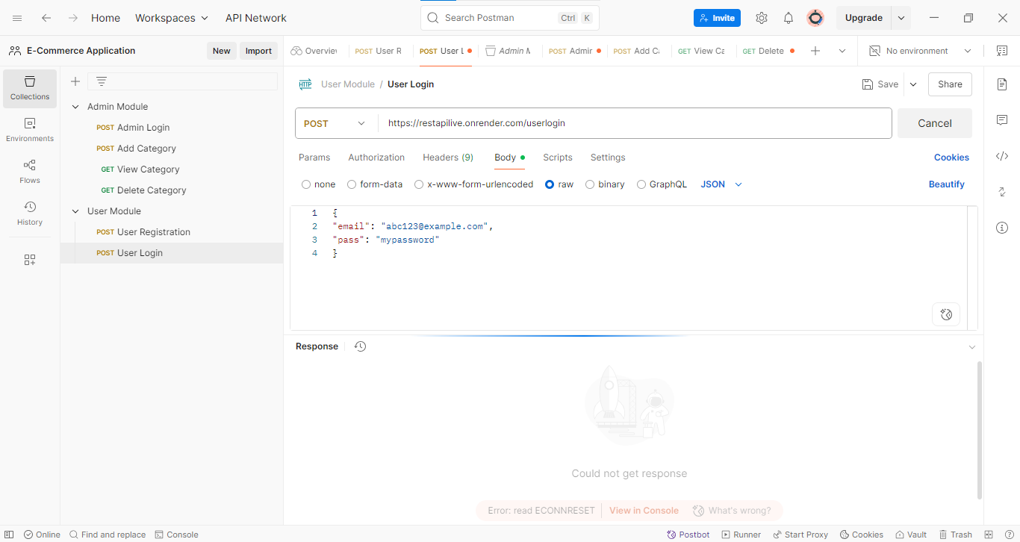

3) to test in above API which is performed login wit using parameter in admin module and check generate

token or not (Method=POST)

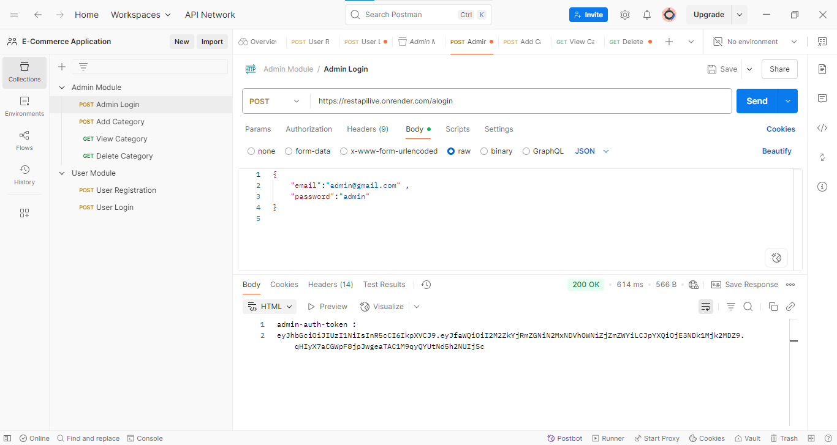

4) to test in above API which is performed login wit using parameter in admin module and check generate

token header : [admin-auth-token : got from admin login] and add category with the help of

token (Method= POST)

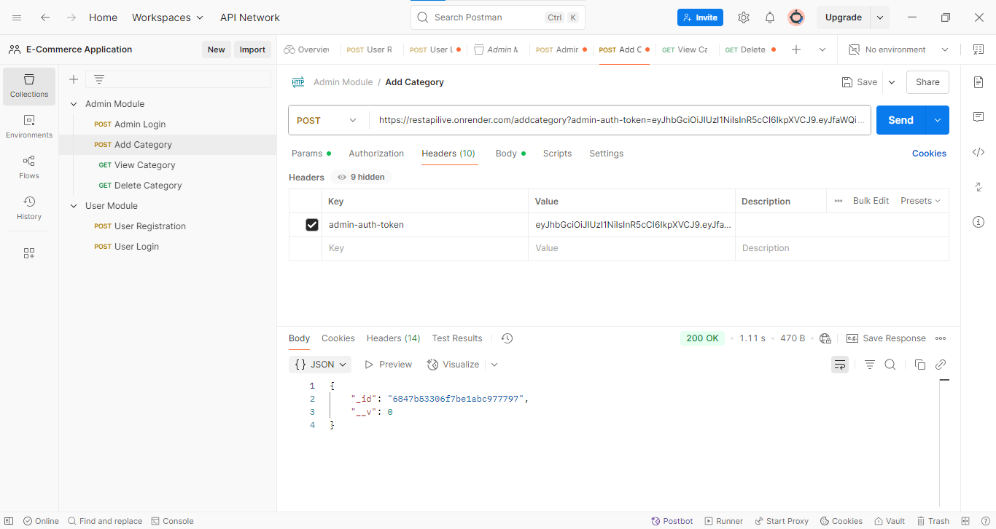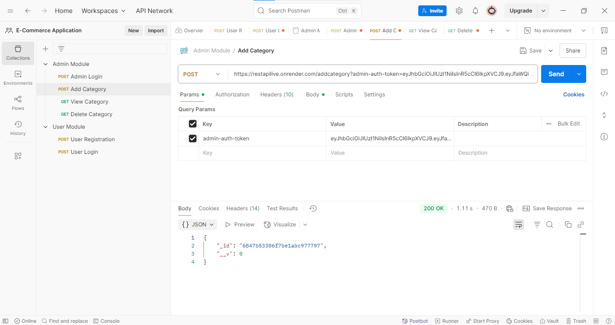

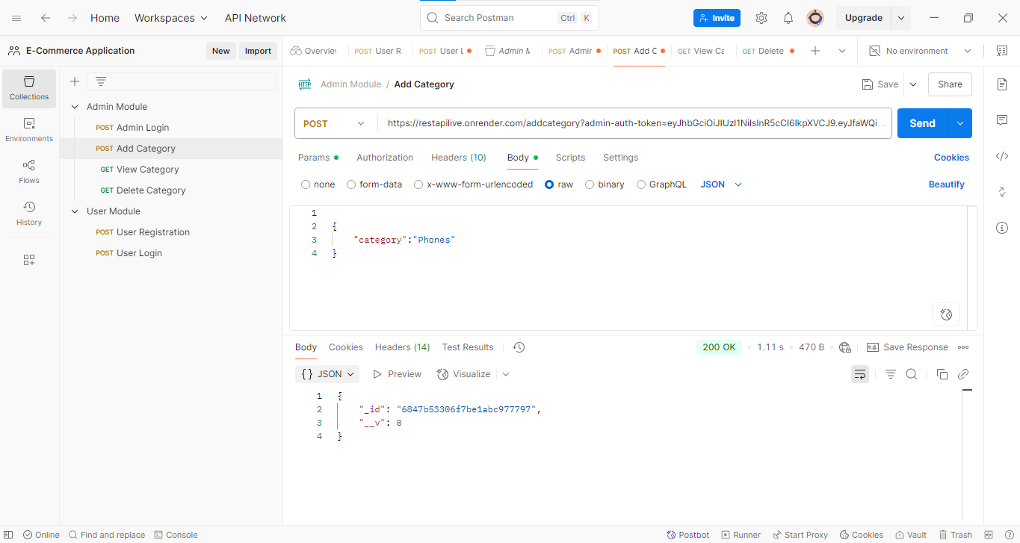

5) to test in above API which is performed login wit using parameter in admin module and check generate

token [admin-auth-token : got from admin login] to display all the category (Method=GET)

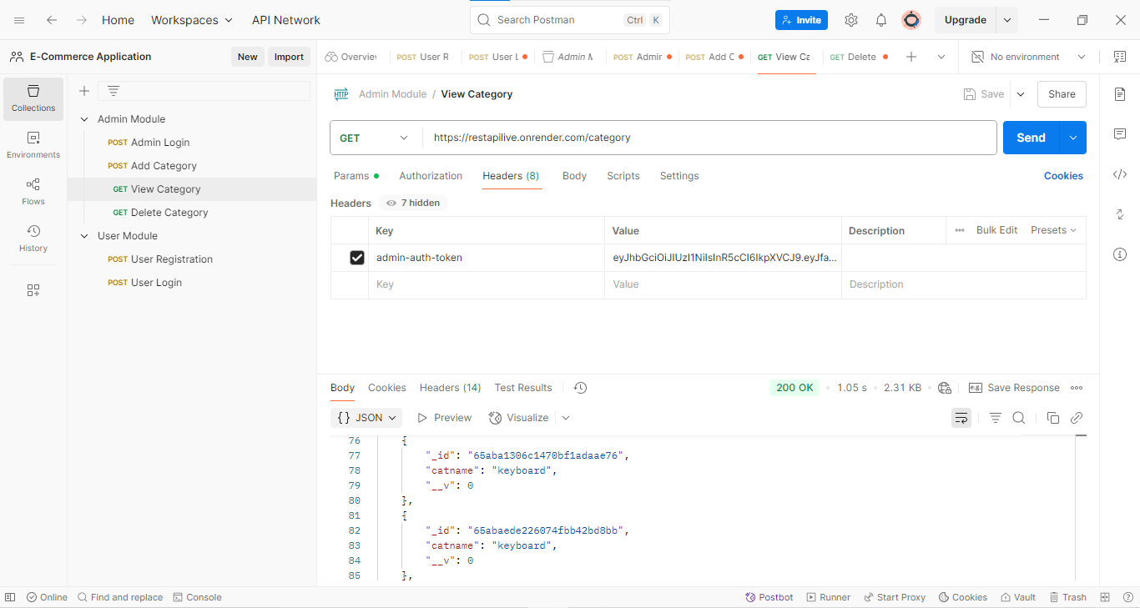

6) to test in above API which is performed login wit using parameter in admin module and check generate

token[admin-auth-token : got from admin login] to delete the category (Method=GET)

